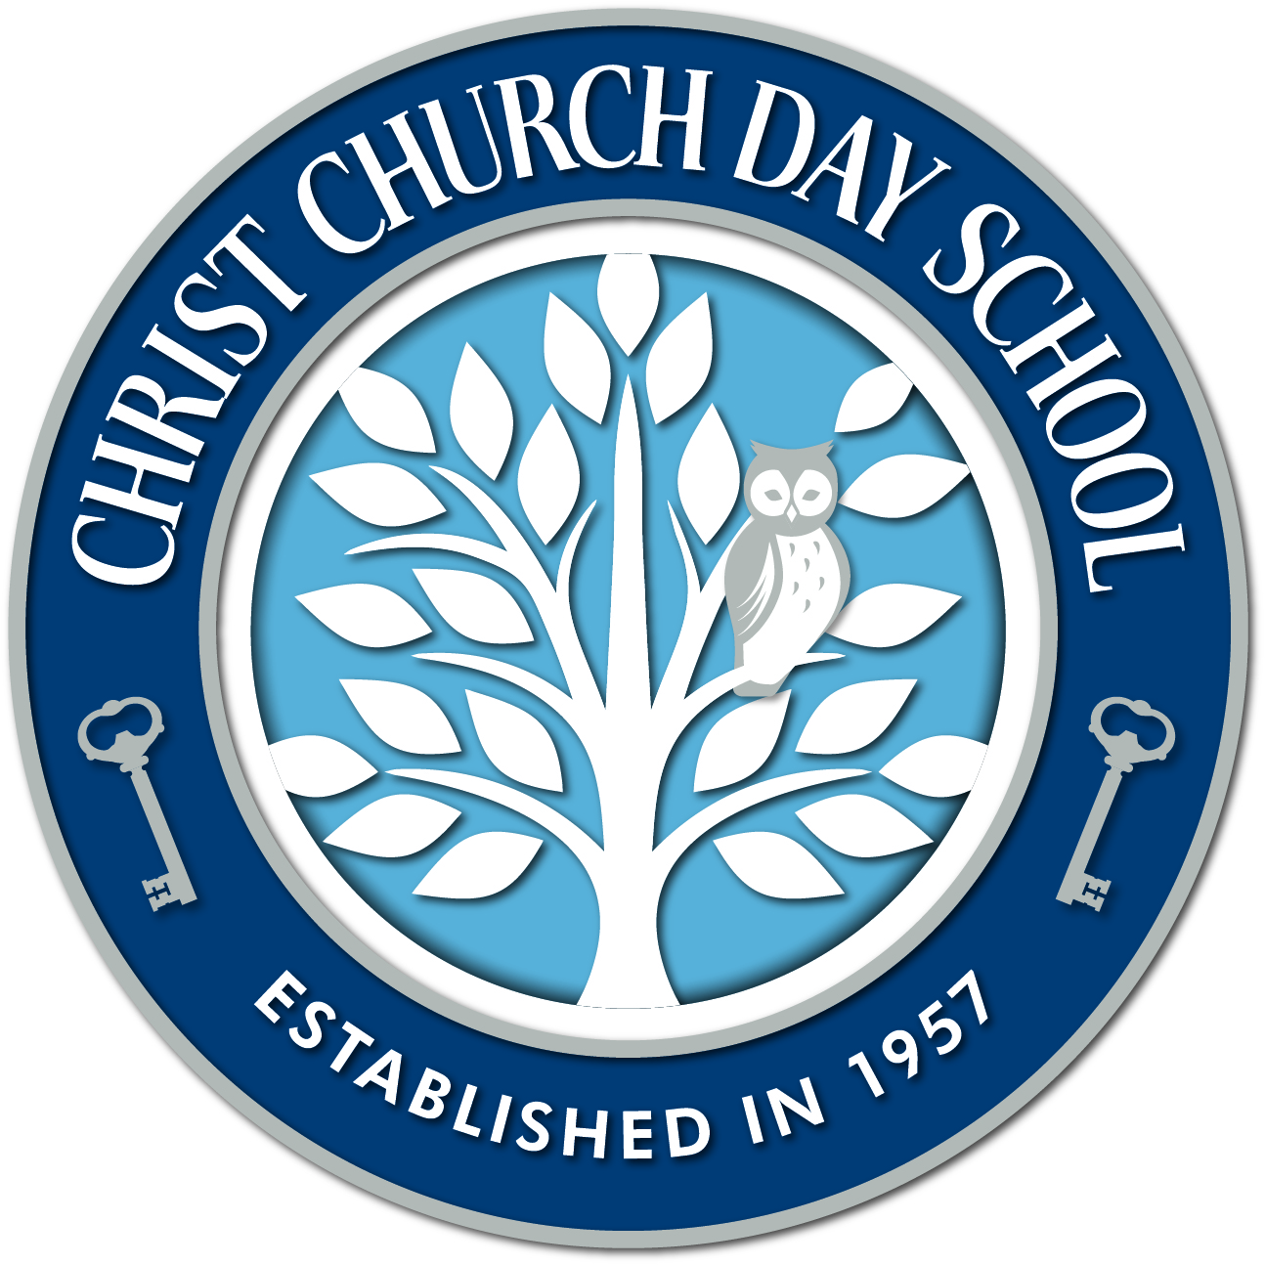
Christ Church Day School
Job description ~ Substitute Positions
Christ Church Day School (CCDS) is a ministry of Christ Church, St. Peter’s Parish located in Easton, MD. We are currently accepting applications for several substitute positions. These positions will vary in terms of class assignment. We have 3 classes: 2s, 3s, and a multi-aged 4s and Year to Grow class. We offer Early Morning Drop-Off and Afternoon Enrichment Programs. School is in session Monday through Thursday. CCDS philosophy is consistent with good practices in the world of preschool education. We are Montessori-inspired and take a playful and active approach to guiding young children. Our program encourages and promotes self-expression, independence, social and spiritual growth as well as a love of learning.
We are looking for substitutes anxious to learn about Montessori philosophy and methodology to further the goals of Christ Church Day School and to celebrate our 60th year.
Responsibilities are broken down into several categories:
General Responsibilities:
- Assist in maintaining a harmonious classroom and school environment
- Assist in maintaining a Montessori-inspired classroom and culture paying particular attention to the needs of the children as a group and as individuals
- Be familiar with procedures and responsibilities as outlined by the CCDS Staff Handbook
- To be familiar with the CCDS Parent Handbook

Responsibilities to the Lead Teacher:
- To assist the lead teacher in the learning and understanding of Montessori material
- To assist the teacher during class time by redirecting children to “work” and aiding children who need help
- To inform the lead teacher of any classroom difficulties, including discipline, health, equipment needs, repair and maintenance
- Help the children work cooperatively in an atmosphere of respect using models of behavior and intervention consistent with CCDS values
- Help to supervise children on the playground
- Report accidents and concerns immediately to the teacher and the Director, filling out an accident report if appropriate.

Responsibilities to the Children and Parents:
- Keep information confidential and sign our confidentiality agreement
- Be cheerful, professional, and positive in all dealings with children and parents
- Share all information communicated by parents with the lead teacher
- Allow the children to be as independent as possible and try not to be an obstacle in their growth.
- Love what you do
Classroom and School Responsibilities:
- Share with CCDS staff in the common cleaning of the school
- Share with the teacher each morning and afternoon in the preparation of the classroom maintaining order, and cleanliness of the environment and clean-up at the end of the day
Qualifications:
- Possess good communication skills
- Love working with ages 2-4+
- Must be able to work independently

Requirements:
- A minimum of a High School Diploma or GED
- Experience in Early Childhood Education
- Background and fingerprinting (CCDS expense)
- Completion of Safeguarding God’s Children’s certification (Diocese of Easton)
- Have current CPR, first aid and AED (defibrillator) training or have completed before employment begins (CCDS expense)

Substitutes will be employees of Christ Church Easton, St Peters Parish, the Director of Christ Church Day School the immediate supervisor.
Please submit a Christ Church Day School job application to: by email (in PFD or Word Document), director@christchurchdayschool.org or mail the application to Director, Christ Church Day School, 111 S Harrison Street, Easton, MD 21601 or fax to 410-822-0932.
Thank you, we look forward to hearing from and meeting you.

CCDS/substitute/ 012017/STSDCB

