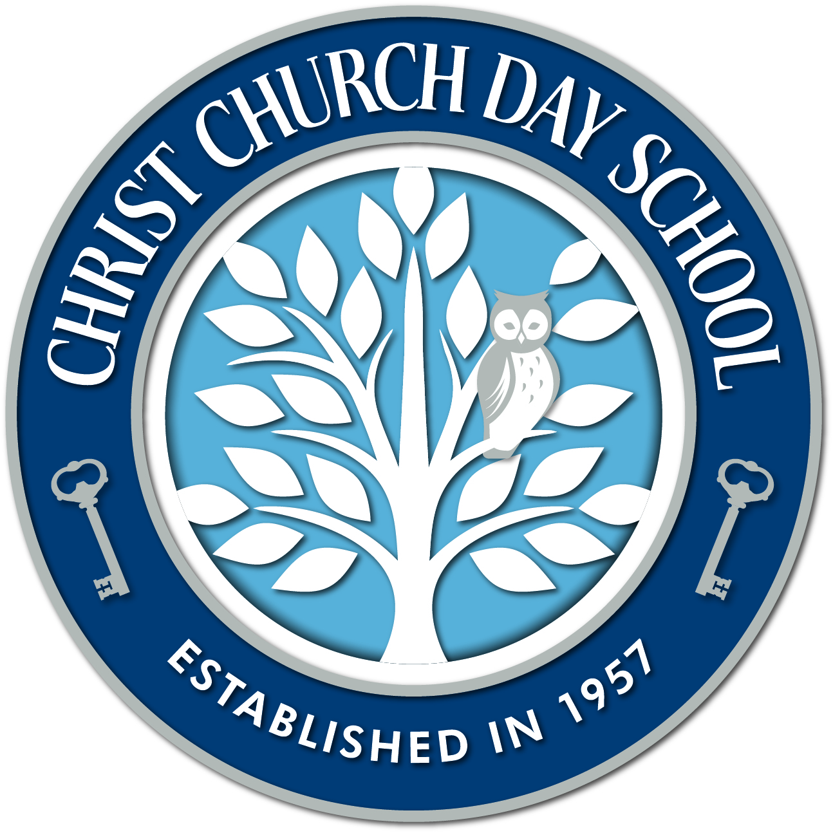
Christ Church Day School
Job description ~ Assistant Positions
Christ Church Day School (CCDS) is a ministry of Christ Church, St. Peter’s Parish located in Easton, MD. We are currently accepting applications for several assistant positions during the 2017-2018 school year, September through May. These positions will vary in terms of class assignment. We have 3 classes: 2s, 3s, and a multi-aged 4s and Year to Grow classes, each class is assigned a teacher and an assistant. We offer Early Morning Drop-Off and Afternoon Enrichment Programs. School is in session Monday through Thursday. Christ Church Day School’s philosophy is consistent with good practices in preschool education. We are Montessori-inspired and take a playful and active approach to guiding young children. Our program encourages and promotes self-expression, independence, social and spiritual growth as well as a love of learning.
We are looking for assistants anxious to learn about Montessori philosophy and methodology to further the goals of Christ Church Day School and to help celebrate our 60th year.
Responsibilities are broken down into several categories:
General Responsibilities:
- Assist in establishing and maintaining a harmonious classroom and school environment
- Assist in establishing and maintaining a Montessori-inspired classroom and culture paying particular attention to the needs of the children as a group and as individuals
- Carefully observe and keep records on each student’s individual progression throughout the classroom, always being available to offer gentle guidance
- Participate in individual meetings with the Director, staff meetings as a group and Montessori trainings
- Participate in all school events, conferences, in-service trainings as directed in the contract
- Carry out specific procedures and responsibilities as outlined by the CCDS Staff Handbook
- To be familiar with the CCDS Parent Handbook
Responsibilities to the Lead Teacher:
- To assist the lead teacher in the learning and understanding of Montessori material
- To assist the teacher during class time by redirecting children to “work” and aiding children who need help
- To be informed and carry out assigned duties with the lead teacher
- To inform the lead teacher of any classroom difficulties, including discipline, health, equipment needs, repair and maintenance (and The Director)
- To meet with the lead teacher to discuss goals for the class and individual students
- Provide direct instruction and/or remedial help as directed by the teacher
- Help the children work cooperatively in an atmosphere of respect using models of behavior and intervention consistent with CCDS values
- Help to supervise children on the playground
- Report accidents and concerns immediately to the teacher and the Director, filling out an accident report if appropriate.
- Help the teacher make material and plan activities
- Substitute in the case of illness or absence
Responsibilities to the Children and Parents:
- Keep information confidential and sign our confidentiality agreement
- Be cheerful, professional, and positive in all dealings with children and parents
- Share all information communicated by parents with the lead teacher
- Allow the children to be as independent as possible and try not to be an obstacle in their growth.
- Love what you do
Classroom and School Responsibilities:
- Share with CCDS staff in the common cleaning of the school between weekly Church Sexton cleanings
- Share with the teacher each morning and afternoon preparation of the classroom maintaining order, and cleanliness of the environment , and clean-up at the end of the day
- Share with the lead teacher the preparation and maintenance of the classroom at the beginning of the year, throughout the year and inventory the class at the end of the year
Qualifications:
- Possess good communication skills
- Love working with ages 2-4+
- Must be able to work independently
- Experience in an early childhood setting
Requirements:
- A minimum of a High School Diploma or GED
- Must be vetted with a background check and fingerprinting (CCDS expense)
- Must have completed Safeguarding God’s Children certification (Diocese of Easton) or have completed prior to start date(no cost)
- Have current CPR, first aid and AED (defibrillator) training or have completed or prior to start date (CCDS expense)

Assistants will be employees of Christ Church, St Peters Parish; The Director of Christ Church Day School the immediate supervisor.
Please submit a Christ Church Day School job application to: by email- (n PDF or Word Document form) director@christchurchdayschool.org or mail the application to Director, Christ Church Day School, 111 S Harrison Street, Easton, MD 21601, or FAX 410-822-0932
Thank you, we look forward to hearing from and meeting you.

CCDS/jobdescription/assistant- / 022017/STSDCB

